**Q )Write a program for generating derivation sequence / language for the given sequence of productions – Grouping, Validating phone Number & Email_id.**

**INPUT (Valid email & phone no): -**

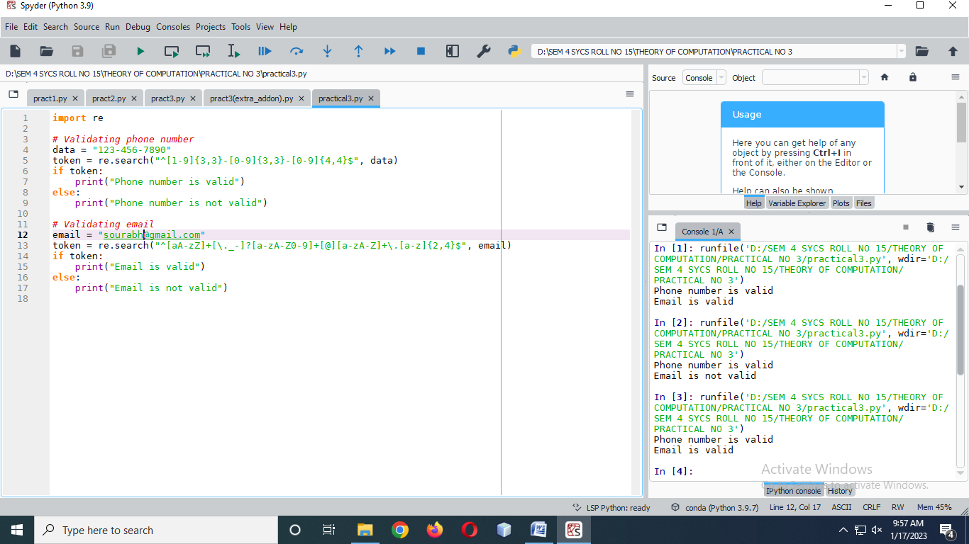

**OUTPUT : -**

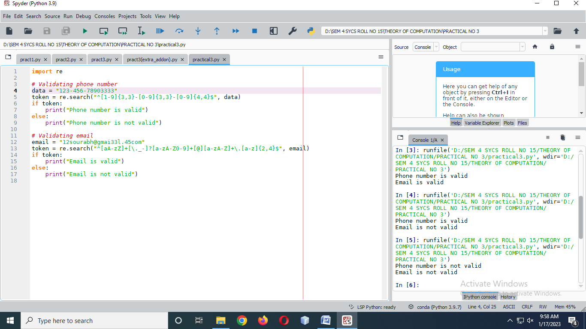

**INPUT (Wrong email and phone no) : -**

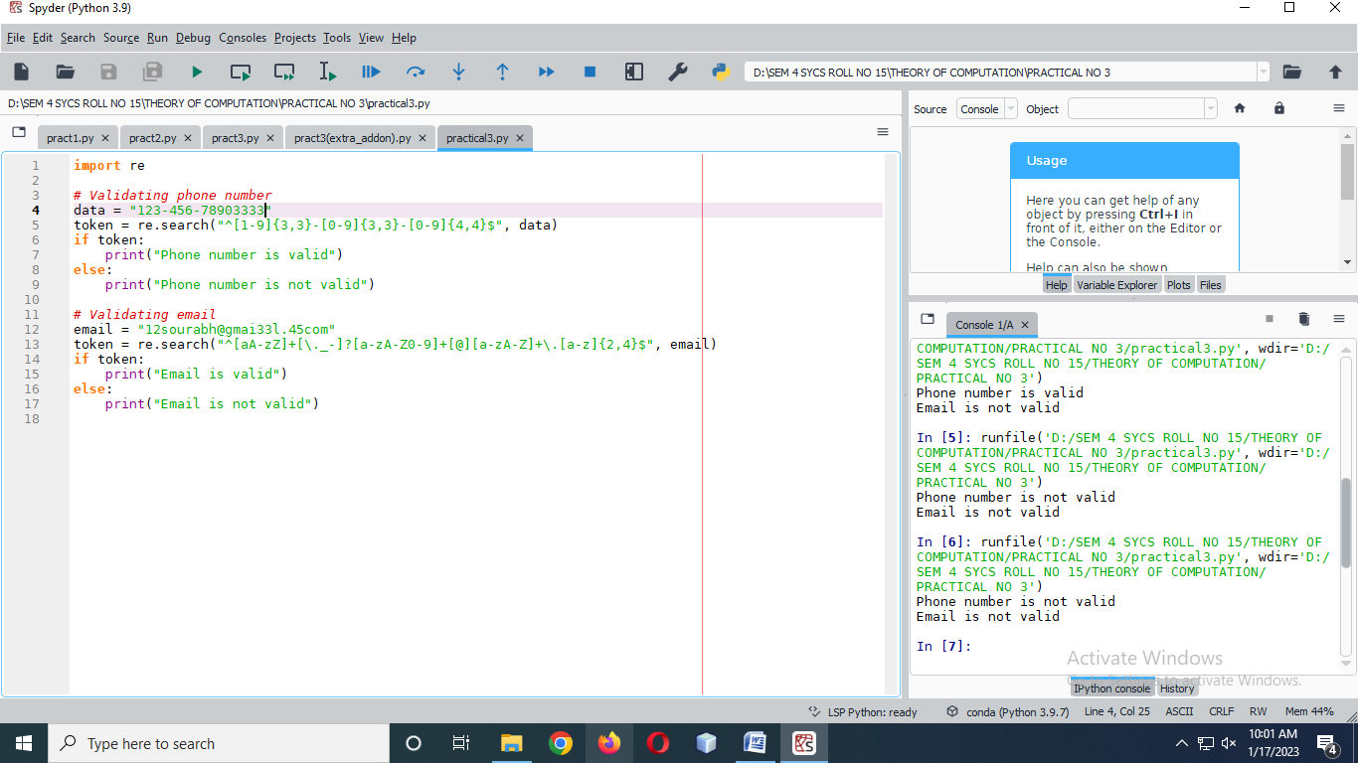

**OUTPUT : -**



* **Grouping : -**

**INPUT : -**

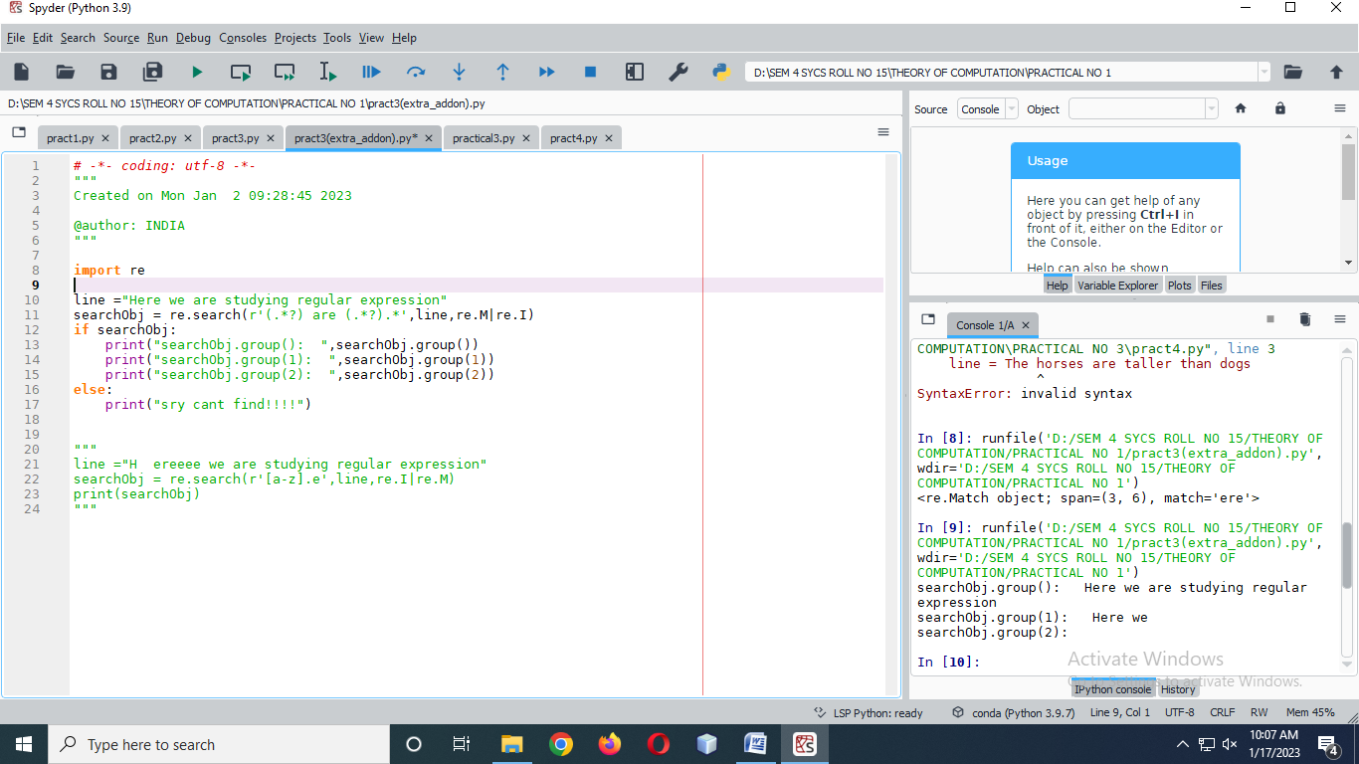

**OUTPUT : -**



**INPUT : -**

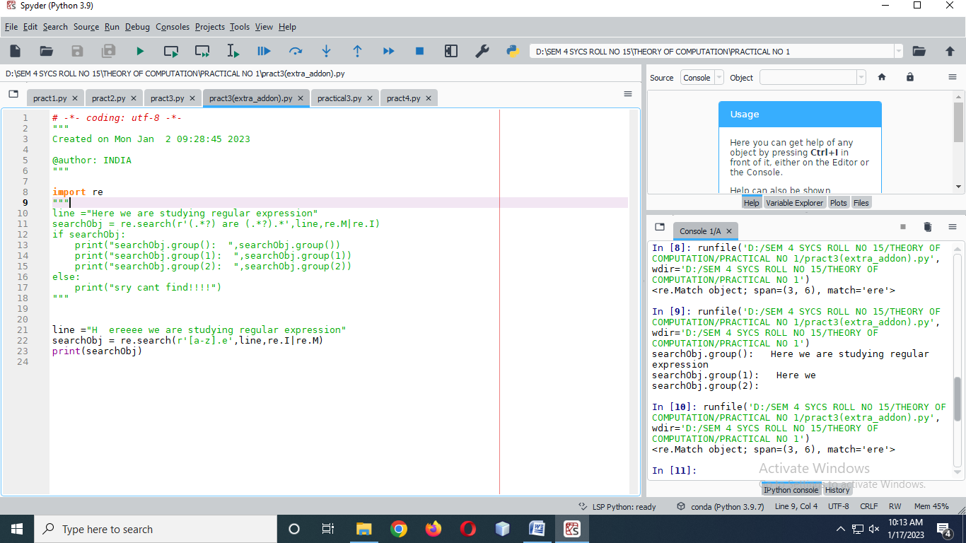

**OUTPUT : -**

